The Society of
Akron Graduate
English Scholars

Presents the Fifth Annual Interdisciplinary Conference

Beyond the Body:
Explorations in Posthumanism and
Transhumanism

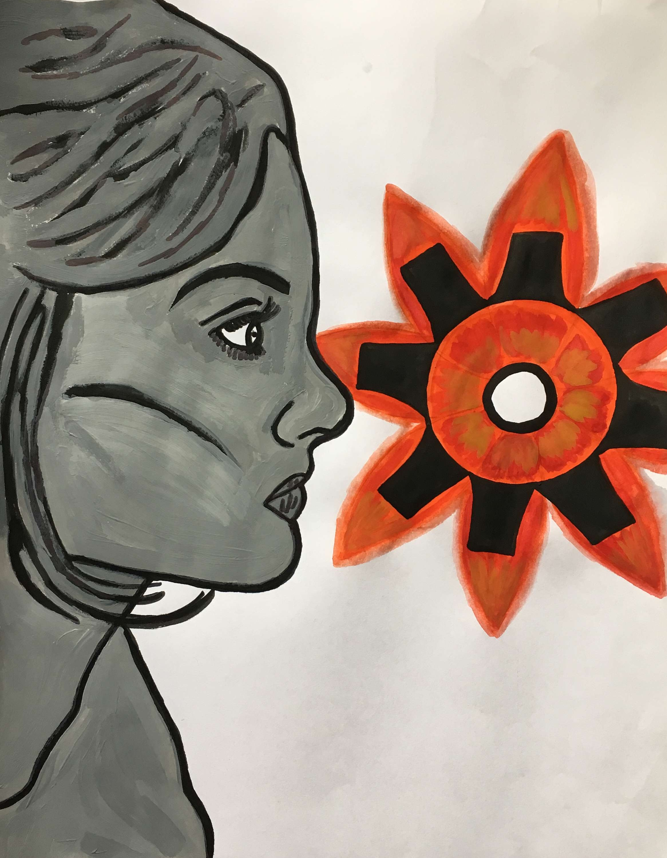

Thursday, March 16th 2017
The University of Akron
Student Union Rooms 312

Acknowledgements

This interdisciplinary conference was made possible by the support and contributions from the members of the Society of Akron Graduate English Scholars, who participate in meetings and in fundraisers needed to run this event.

Special recognition to the SAGES officers: Kayla Hardy-Butler (President), Melissa Perkins (Vice President), Elizabeth Hall (Secretary), and Casey Kuhajda (Treasurer).

A special thank you to our SAGES leadership team who helped prepare this conference. Without their help, this conference would have not been possible.

This conference was organized by Rita Stricklin (Conference Chair), with the help of Kaylor Montgomery (Conference Co-Chair), Nichols DeCourville (Conference-Co-Chair), and Devon Fairchild (Conference Co-chair) all of whom collaborated in every aspect of this conference, as needed with planning, advertising, and logistics.

Many thanks to Dr. Hillary Nunn, our faculty advisor, for her continued support and dedication to this organization and this project. Her insight and guidance keeps SAGES professionally grounded.

We would also like to thank: Dr. Joseph Ceccio, Dr. Sheldon Wrice, and our moderators, Dr. Hillary Nunn, Dr. Heather Braun, Dr. Philathia Bolton, and Professor David Giffels.

Special thanks to Lauren Simmers, for providing the artwork for today’s program.

Panel Schedule

8:30AM-9:45AM:

The Gendered Body

Sara Santos, Stony Brook University

“A Carnivorous Relationship: The Corporatization and Animalization of the Female Body in Margaret Atwood’s Oryx and Crake”

Nichols Paul deCourville IV, The University of Akron

“The Subversive Alisoun: The Question of Trans-Identity in The Wife of Bath’s Prologue”

John Heggestad, Stony Brook University

“The Ungainly Attendant: M’ling’s Multi-Otheredness in The Island of Doctor Moreau”

10:00AM-11:15AM

The Personal Body

Penelope Jeanne Brannen, The University of Akron

“AUTOXENOPHILA – the new self-love and trans feminine survival in the beyond”

Kathryn Stephan, The University of Akron

“On the Other Side of the Door”

Madebo Fatunde, The University of Akron

“What’s in a Gaze”

11:30 AM - 12:45 PM:

Identity

Casey Kuhajda, The University of Akron

“When the Pastoral and Industrial Collide: Objects as Prime Narrative Movers in Adventures of Huckleberry Finn, Moby Dick, The Sound and the Fury, and Native Son”

Anna Glotzer, The University of Akron

“Richard Wright’s Bigger Thomas & Paul Robeson’s Othello: Representations of Physicality in Male Blackness”

Kayla Hardy Butler, The University of Akron

“Le Guin’s A Wizard of Earthsea: The Doppleganger As the Expression of Evolved Identities”

LUNCH BREAK: 12:45-1:45

2:00PM-3:15PM

Outside the Body

Elizabeth Hall, The University of Akron

“Engaging with ‘The Machine’: Technological Transformations of Twenty-First Century Rhetoric”

Céline Cregut, The University of Akron

“Geniuses without a Body: how pop culture defines a ‘great mind’”

3:30PM-4:30PM

The Creative Body

Scot Piepho, The University of Akron

“Processing Time Remaining”

Amanda Miller, The University of Akron

“Posthumous”

Jonathan Wlodarski, Youngstown State University

“Dirt”
Keynote Address

Dr. Todd Comer

"Birth and the Mourning after: Posthumanism"

4:45-6:15

Dr. Todd Comer is a Professor of English at Defiance College. Comer’s work merges the insights of postmodern theory, ecocriticism, disability studies, and postcolonial studies. Comer has edited three books focused on Alan Moore, terror and cinema, and OWS politics; he is currently writing a book-long ecological analysis of the films of Peter Weir (Bloomsbury). His other incipient book, Birth and the Mourning After: Contemporary Fiction and Film, argues for birth as the dominant fact of our existence, as that state within which the posthuman dwells.

Presenters

Scott Piepho realizes that he is expected to write something whimsically amusing in his biography, but he doesn’t do that well, and what’s more he finds current writer bio conventions a bit grating. So he’ll just say that he’s an award-winning freelance journalist who studies creative nonfiction in the NEOMFA program. His fiction has been published in The First Line and on writermag.com.

Penelope Jeanne Brannen is a transgender lesbian cyborg from the future. She is a first year poet in the NEOMFA through Cleveland State University. In her free time she posts w4w missed connections on Craigslist based on her dreams.

Kathryn S. Stephan is a class of 2018 Master of Fine Arts candidate, concurrently at The University of Akron and in the Northeast Ohio Master of Fine Arts (NEOMFA) consortium, with a focus on Creative Non-fiction. She holds a Bachelor of Arts in Creative Writing from Ohio University in Athens, Ohio, and is very excited to be back in school, studying, teaching, and serving on the editorial board of The University of Akron's graduate literary journal, The Rubbertop Review. She enjoys writing about relationships, family, and her own sanity or lack thereof. This marks Katie’s second year presenting at the Society of Akron Graduate English Student’s conference.

Sara Santos is a PhD student in English at Stony Brook University, and has a Masters from the University of Lisbon. She studies biopower and environmental criticism in late 20th century and contemporary literature. Her work focuses on the tenuous boundaries between human and nonhuman bodies, and the way in which contemporary narratives work to redefine the concept of the human through the intertwining of capital, technology and environment
Casey Kuhajda completed his undergraduate studies at John Carroll University, graduating with a B.A. in English Literature and minors in History and Philosophy. He is currently a Teaching Assistant and a graduate student in the department of English at the University of Akron. Today he will be presenting selections from his Master’s Thesis which focuses on American literature in the 19th and 20th centuries. He is interested in how textual objects within modern American Literature serve to simultaneously form and frame narrative structures.
Amanda Miller grew up in a house where there was healthy conversations about aliens, fairy tales were normalized, and she was encouraged to consult the Ouija board about dead ancestors. Currently, she is a graduate assistant at Youngstown State University where she runs a community Creative Writing Group and is the poetry editor for Jenny Magazine. Things never get weird enough for her.

Madebo Fatunde are two of a dozen names this mouth will answer to. He is Black, radical, Yoruba, southern, sleep-deprived, and a shinobi of the village hidden in the clouds. A first-year poet in the NEOMFA and an MS candidate in the University of Houston’s Foresight program, his research interests include futures of IP law, ludonarrative, blockchain, creative labor, human-machine interfaces, and interactive media. If you take nothing else away from this meeting, remember: God is a virus of language. Stories are processors. The data transference of your somatic DNA is roughly 500TB/second. Marvel & recoil. [end transmission]

Jonathan Wlodarski is a fiction student in the Northeast Ohio MFA. He has been published in Riprap, Eureka Literary Magazine, and FLAPPERHOUSE, among other venues.

Céline Cregut graduated in 2005 in Lorient, France with a BA in English and American Literature and Language. She got a degree in Business Management in Brest, France, and worked as a manager in several department stores until going back to school in 2013. She got a Master’s degree in English and American literature from the University of Le Mans, France, in July 2016. She is now a teacher’s assistant in the Modern Languages department at the University of Akron. She assists Pr. Maria Adamowicz-Hariasz with her French Culture class. She is currently working on her PhD thesis (University of Le Mans, France, and University of Edinburgh, Scotland). Her research focuses mainly on the male vampire and the notions of icon/figure/myth.

Elizabeth Hall is completing the last year of her Master's program in English Composition and Rhetoric at the University of Akron. She will also earn a certificate in Teaching English as a Second/Foreign Language when she graduates in May. She graduated summa cum laude from Kent State University and earned her B.S.E. in Integrated Language Arts in 2013. She plans to publish her first academic article, "'When one shingle sends up smoke': The Summit Beacon Advises Akron about the Epidemic Cholera, 1849" in Nineteenth-Century Ohio Literature later this spring.

Jon Heggestad is a first year PhD student in Stony Brook University's English department. His main academic interests center around Victorian studies, queer theory, and digital humanities (especially when they overlap).

Nichols deCourville. is a graduate student at The University of Akron, and is graduating in May. In addition to being a teaching assistant, Nichols has also been compiling his thesis concerning the Bronte sisters and the punk-band Crass. Nichols hopes to attend an M.F.A. program after completing his M.A., though is still eagerly anticipating the day he hears back from any of his schools. Outside of college, Nichols plays in several Punk bands throughout Akron, Ohio, and one day wishes to travel to the far reaches of outer-space.

Anna Glotzer is a graduate student at The University of Akron, studying English Literature. She also attended undergraduate at The University of Akron (B.A. in English). She currently works as a freelance writer at The Akronist as a contributor to the Arts and Culture section while tutoring students in the writing lab. With critical insight to the arts, her current work reflects interest in exploring the socio-political dimensions connected to the presence of people of color in contemporary literature.

Kayla Hardy-Butler is a graduate assistant in the English Department at The University of Akron where she is completing her Masters of Arts in English Literature, teaches English Composition, and graduated with her B.A in English Literature with minors in creative writing and popular literature and film. She currently serves as the President of SAGES and as the treasurer for The Upstart Crows. Her interests include fiction writing, young adult literature, and American literature with attention to the gothic, folklore, and racial dynamics. She plans to pursue PhD studies with specific attention to creative writing. She enjoys singing, writing, spending time with her dogs, and reading mythology and folklore, both of which serve as influences for her creative writing.



The Society of Akron Graduate
English Scholars

SAGES is a student organization open to all English graduate students of all tracks that focuses on helping all tracks develop professionally during their time at the University of Akron. We work to provide members with tools to help them publish, present, and prepare for the future.

This organization also strives to promote unity among its members by creating events, providing resources, and visiting places that will benefit the pursuits of each track (Composition, Fine Arts, and Literature).

Disclaimer: This student organization is a registered student organization at The University of Akron. Registration shall not be construed as approval, endorsement, or sponsorship by The University of Akron of the student organization’s publications, activities, actions, or positions.
Notes

Notes

